Project Design Phase-II Technology Stack (Architecture & Stack)

|  |  |
| --- | --- |
| Date | 22 October 2022 |
| Team ID | PNT2022TMID38637 |
| Project Name | REAL TIME RIVER WATER QUALITY MONITORING AND CONTROL SYSTEM |
| Maximum Marks | 4 Marks |

Technical Architecture:

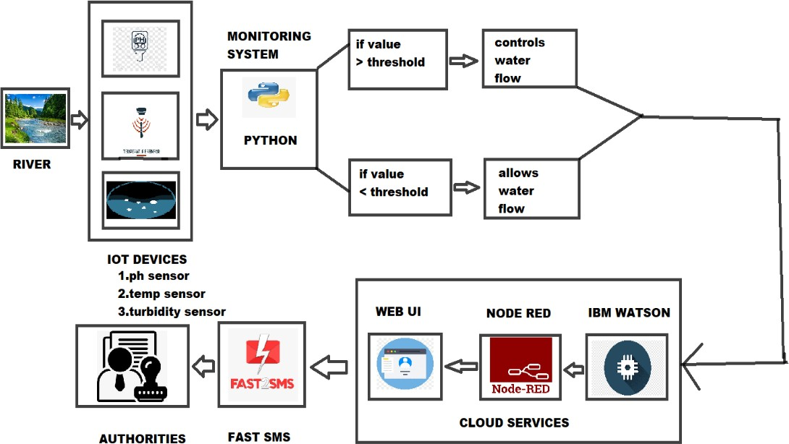

Table-1 : Components & Technologies:

|  |  |  |  |
| --- | --- | --- | --- |
| **S. No** | **Component** | **Description** | **Technology** |
| 1. | User Interface | The UI is the point of human computer interaction and communication in a device | WEB UI. |
| 2. | Application Logic-1 | Logic for a process in the software application | Python. |
| 3. | Application Logic-2 | Data are stored in the cloud | IBM Watson STT service. |
| 4. | Application Logic-3 | Logic for checking the accurate water quality | Quality monitoring system. |
| 5. | Database | The pH, temperature, turbidity values are stored. Data are stored into the system for future references. | MySQL, NoSQL. |
| 6. | Cloud Database | A cloud database helps to store, organize and manage data. | IBM Cloudant |
| 7. | File Storage | Files are stored into the system | IBM Cloudant DB Storage and local file system is used. |
| 8. | External API-1 | It is used to get depth data about climate, environment weather for analysis | IBM Weather API, Google Weather API. |
| 9. | Machine Learning Model | It allows the user to feed a computer algorithm an immune amount of data and have the computer  analyse and make data-driven recommendation | Object Recognition model. |
| 10. | Infrastructure (Server / Cloud) | Application Deployment on Local System / Cloud Local Server Configuration Cloud Server Configuration | Node RED. |

Table-2: Application Characteristics:

|  |  |  |  |
| --- | --- | --- | --- |
| **S.No** | **Characteristics** | **Description** | **Technology** |
| 1. | Open-Source Frameworks | Online software tools | Tinkercad, etc. |
| 2. | Security Implementations | Only the authorised users can able to access the data | Encryptions technology is used in it. |
| 3. | Scalable Architecture | This project is scalable because it covers a particular zone | IBM Watson IOT. |
| 4. | Availability | The system is availability for 24/7 for the regular monitoring of quality water | Rechargeable sensors. |
| 5. | Performance | This system works in low power and is highly efficient | IoT, Node RED, Wi-Fi module sensors. |